ORgSys

(Organization Recognition System)

Sequence Diagram

Submitted to:

Asst. Prof. Ma. Rowena C. Solamo

Faculty Member

Department of Computer Science

College of Engineering

University of the Philippines, Diliman

Submitted by:

GRANADA, Patrick James B.

MERCADO, Emir R.

YAP, Sharmaine A.

In partial fulfillment of Academic Requirements

Revision Control

*History Revision:*

| Revision Date | Person Responsible | Version  Number | Modification |
| --- | --- | --- | --- |
| 10/16/2013 | Emir Mercado  Patrick Granada | 1.0 | Initial Document; |
| 10/17/2013 | Emir Mercado | 1.1 | Fixed document layout  Added note on scenarios w/o diagrams |

*System Name*: ORgSys (Organization Recognition System)

*Description*: The system's purpose is primarily to provide the Office of Student Affairs of UP Diliman's College of Engineering a means of evaluating the organizations during their application period for recognition for the whole school year. This system provides a way for the unit heads to upload the documents submitted by the organizations online. It will also serve as a venue for Associate Dean for Student Affairs and the Review Committee to provide the organizations with the list of required documents requirements for approval and to check if the member roster of the organization is valid.

*Use Case Name:* 1.0 Manage Organizations

*Scenario 1:* Create org account

*Sequence Diagram:*

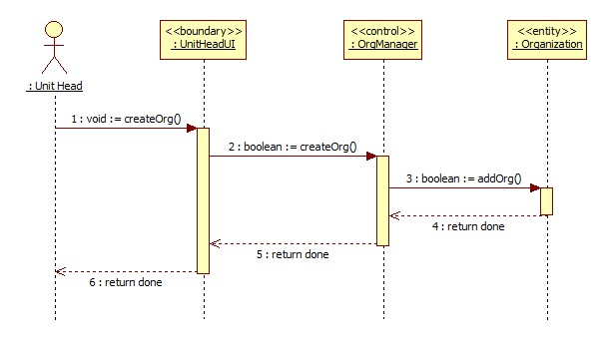

*Scenario 2:* Delete current documents

*Sequence Diagram:*

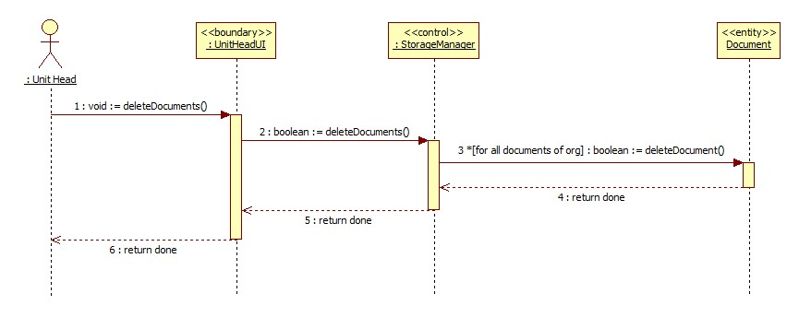

*Scenario 3:* Delete documents

*Sequence Diagram:*

The Online Storage actor is implemented as the StorageManager control class and therefore has no sequence diagram.

*Scenario 4:* Upload documents

*Sequence Diagram:*

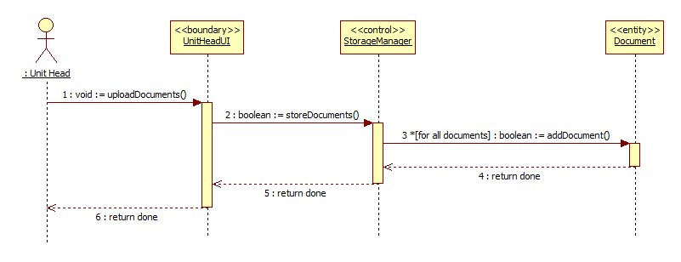

*Scenario 5:* Store documents

*Collaboration Diagram:*

The Online Storage actor is implemented as the StorageManager control class and therefore has no sequence diagram.

*Use Case Name:* 2.0 Manage Requirements Checklist

*Scenario 1:* Delete old requirements list

*Sequence Diagram:*

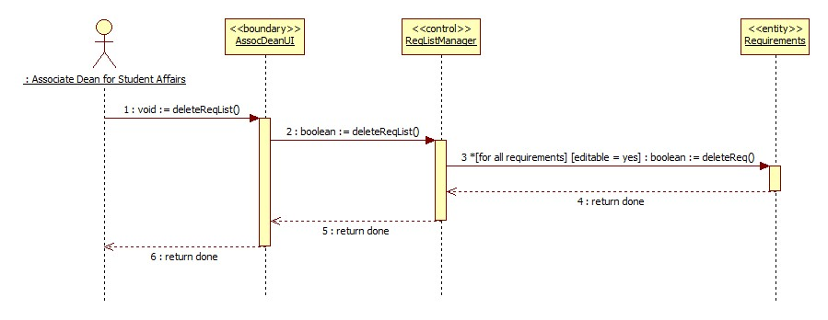

*Scenrario 2:* Create new requirements list

*Sequence Diagram:*

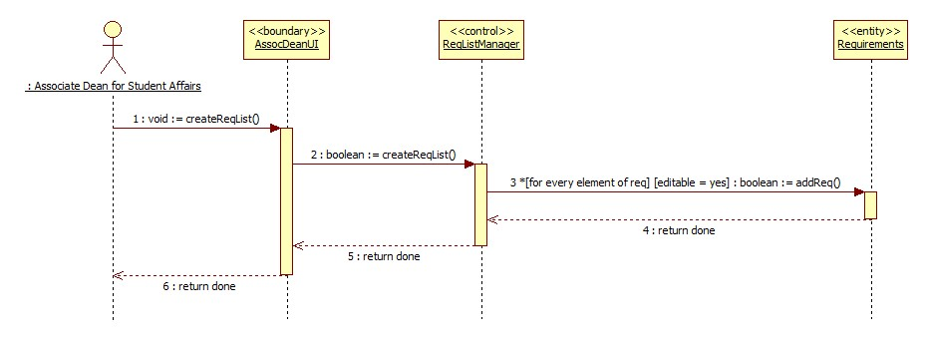

*Scenrario 3:* Finalize requirements list

*Sequence Diagram:*

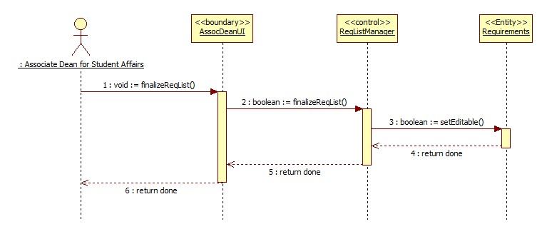

*Use Case Name:* 3.0 Review Orgs for Recognition

*Scenario 1:* Provide Organizations' documents

*Sequence Diagram:*

The Online Storage actor is implemented as the StorageManager control class and therefore has no sequence diagram. Moreover, the organizations' documents are already made available in the system thus having no need to provide it.

*Scenario 2:* Upload list of enrolled students

*Sequence Diagram:*

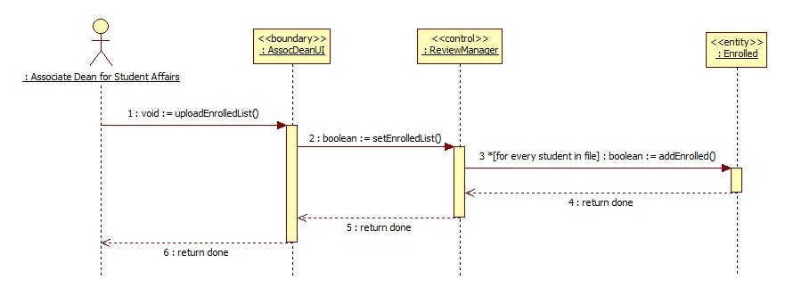

*Scenario 3:* Validate org members

*Sequence Diagram:*

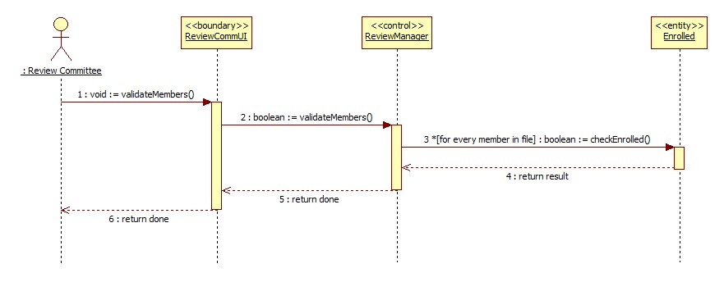

*Scenario 4:* Evaluate submitted documents

Sequence *Diagram:*

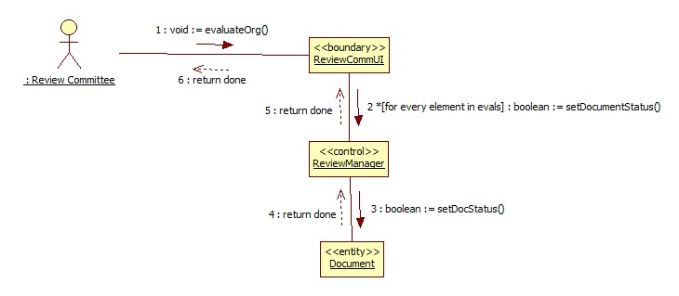

*Scenario 5:* Finalize list of approved orgs

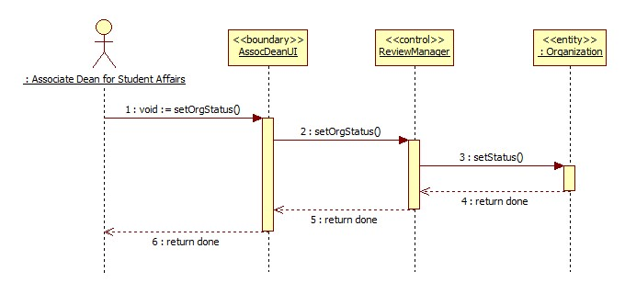

Sequence *Diagram:*

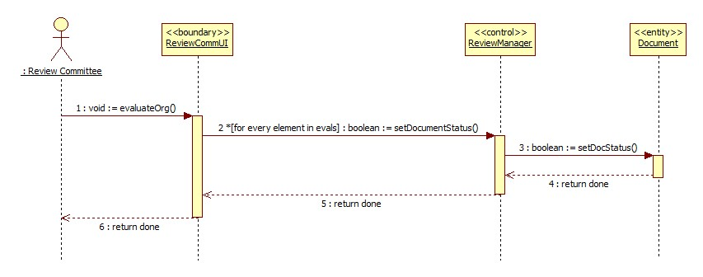

*Use Case Name:* 4.0 View Recognition Status

Sequence *1:* View org status

*Sequence Diagram:*

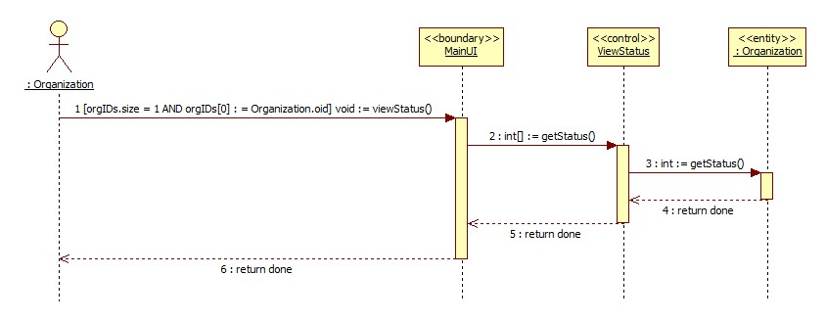

*Scenario 2:* View dept. org status

Sequence *Diagram:*

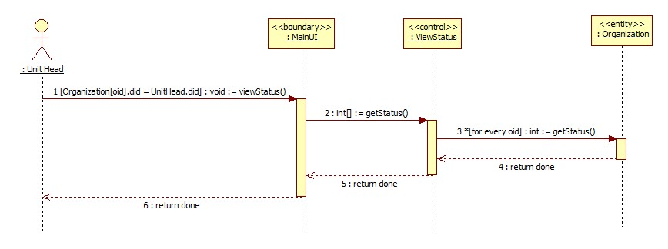

*Scenario 3:* View all org status

Sequence *Diagram:*

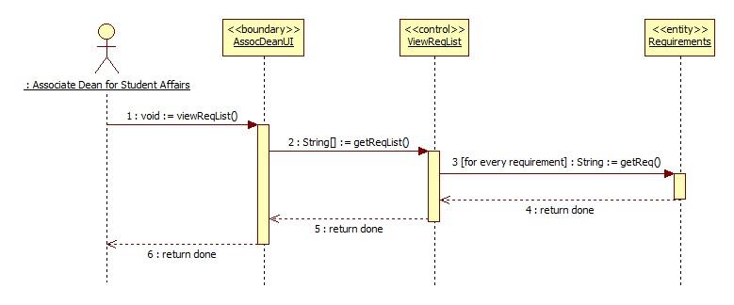

*Use Case Name:* 5.0 View Requirements Checklist

*Scenario 1:* View requirements checklist

*Sequence Diagram:*

